RepRapPro Tricolour Mendel

Introduction
These pages are the complete instructions for building, commissioning and using the RepRapPro Ltd version of RepRap Mendel.
Like all RepRap machines, RepRapPro Tricolour Mendel is fully open-source. It is licenced under the GPL. All the design files and software are available from the RepRapPro Ltd Github repository. And it is here in the Thingiverse.
If you want to print the plastic parts for a RepRapPro Mendel, see this wiki page.
RepRapPro Tricolour Mendel is based on the previous RepRap Pro Mendel with many alterations and additions. It was designed in order to further simplify assembly and to increase build volume when using multiple extruders.
These inital instructions document the assembly of a single material/colour “Mono” Mendel. It is recommended that even multicolour machines are initially assembled as Mono Mendels, before being extended to Tricolour machines after a commissioning.
General notes
Give yourself plenty of space and ensure your work area is clean. Dust and dirt are a 3D printer's worst enemy. All printed parts have been printed on various RepRap machines from suppliers within the RepRap community. Despite the fact that these machines are highly tuned RepRap 3D printers, some holes and features may need a little fettling to get the best performance from your machine. This is especially true for the Igus bushings used for the Z axis. There is a video how-to on fettling 3D printed parts here on Vimeo.
Before you start the build, please ensure you have all the components as listed on the packing list included in the kit. If anything is missing, please contact us via email:
BEFORE YOU ATTEMPT TO ASSEMBLE ANY PART OF THE RepRapPro Mendel 3D PRINTER, PLEASE READ THESE BUILD INSTRUCTIONS FULLY AND ENSURE YOU UNDERSTAND THEM. Although all parts are covered by warranty, this will be invalidated by your not following these build instructions. If anything is unclear please get in contact with support prior to assembly in order to ensure no damage caused to your machine.
The RepRapPro Mendel is a robust RepRap machine once assembled; however it does require a certain amount of care during assembly. If in doubt, force is usually not the answer! There are many ways to get support and advice, see the Get Support section below.
If you can't see clearly from the pictures, they can be enlarged by clicking on them
Table of Contents
- Frame assembly
- Y axis assembly
- X axis assembly
- Z axis assembly
- Heated bed assembly
- Extruder drive assembly
- Hot end assembly
- Power supply
- Wiring
- Commissioning & Software Installation
- Printing
- Multi-colour/multi-materials
- Maintenance
- Troubleshooting
- Improvements

Get support
If you find you need help or advice with assembling, commissioning or using your RepRapPro Mendel 3d printer, you can use the following channels:
- Our Forum. This sub-forum deals with the RepRapPro Mendel. Other sub-forums on the site deal with other eMaker and RepRapPro models.
- RepRapPro/eMaker channel on freenode irc

Tool List
Mechanical
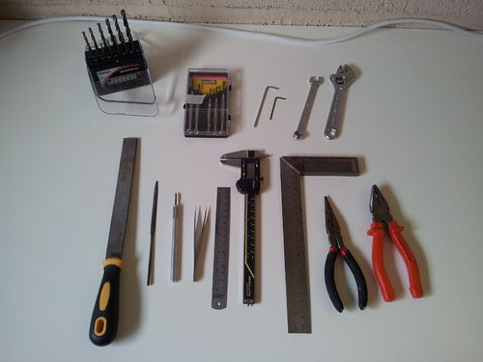
Tools required for the mechanical build of the RepRapPro Mendel 3D printer:
- Drill bits including 2mm, 3mm, 6mm and 8mm
- Precision screwdriver set
- A set of metric allen keys including:
  - 2mm (M2.5 size)
  - 2.5mm (M3 size)
  - 4mm (M5 size)
- 13mm spanner (M8 nut)
- 8mm spanner (M5 nut)
- 5.5mm spanner (M3 nut)
- 5mm spanner (M2.5 nut)
- 15cm adjustable spanner
- File
- Half round needle file
- Craft knife
- Fine tweezers
- 300mm rule
- Vernier or digital calipers
- Square
- Fine nosed pliers
- Pliers
- Side cutters
- A small amount of superglue (for securing the hobbed insert)

Electrical
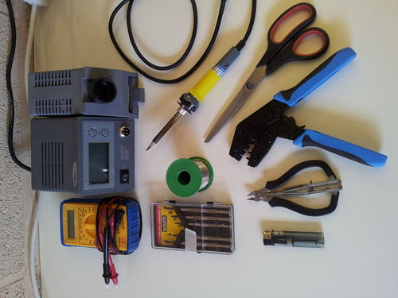
Tools required for the electrical build of the RepRapPro Mendel 3D printer:
- Digital Multimeter
- A fine-tipped soldering iron
- Precision screwdrivers
- Solder
- Hair dryer or cigarette lighter (or other heat source for heating heatshrink wire sleeving; the barrel of a soldering iron works OK)
- Wire strippers/cutters
- Ratchet crimp tool
- Molex crimp tool (such as the 63811-1000, you may also want the extraction tool 11-03-0044, Molexkits.com)
- Scissors

Next step

Frame assembly

